1. What is a Sole Trader?

A sole trader is a person who owns their own company and keeps full liability over a business, such as taxi drivers and plumbers.

1. What are the advantages of setting up a sole trader business?

It is easy to set up as there is not much paperwork to fill in, you are the only person that matters as you make all of the decisions yourself, you get all of the pay as you do not need to pay anyone else, you have a very low tax rate and you are your own boss.

1. What are the disadvantages of setting up a sole trader business?

If you are ill you will not get paid, you could fall into debt and have to repay the debt by selling your personal objects, you may have to work long hours, you have unlimited liability and if you do not open you will not get paid.

1. What is unlimited liability?

You have sole responsibility for the business; you would have to pay off all debts which may have to be settled by selling your own personal possessions. With this you will get a higher chance of getting a loan as if you get into debs all the money gets paid back to the lenders.

1. Name a “sole trader” that you are aware of and find two images of this from the internet.

Bradwell Butchery

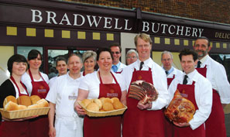 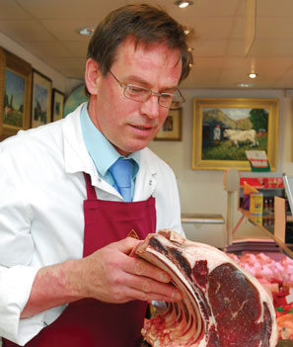

1. What is the purpose of the company? What services do they provide?

The purpose is to sell food to the customers; they provide multiple types of meat to the masses.

1. It is a small business as it has less than 99 employees and is a small scale as it sells at a small rate.
2. Local competitor: Keith's Butchers, as they are butchers selling similar prices in the same area.
3. National Competitor: Tesco, as they sell everything on a bigger scale at lower costs across the U.K.
4. The links between ownership and size and scale: A sole trader will have a small business with a small size of employees and a small scale of good soled, unless for example, they have an online shop in which case they may have a small size but have a big scale as they can sell all over the world. In this case the business has small size as there are less than 99 employees and small scale as it only sells to customers in-shop.
5. Sectors: Bradwell Butchery is in the tertiary sector as it sells products to people, it is classified this way as it only sells the meat and not breed nor slaughter the meat.